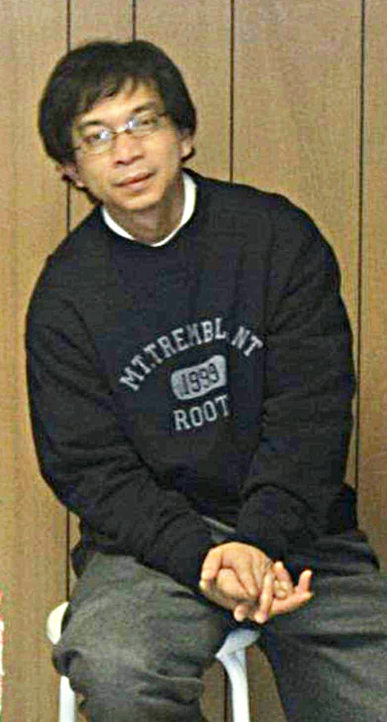

Joseph Jeofrey Lozano Fiesta

April 28, 1968 – October 30, 2023