NANDLALL SINGH 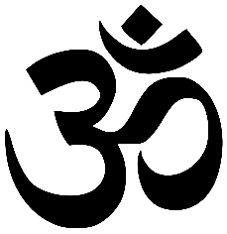

September 8, 1962 – January 12, 2020 SINGH IS KING