王葉秀英太夫人
Wong Yip, Sau Ying
1936 – 2021

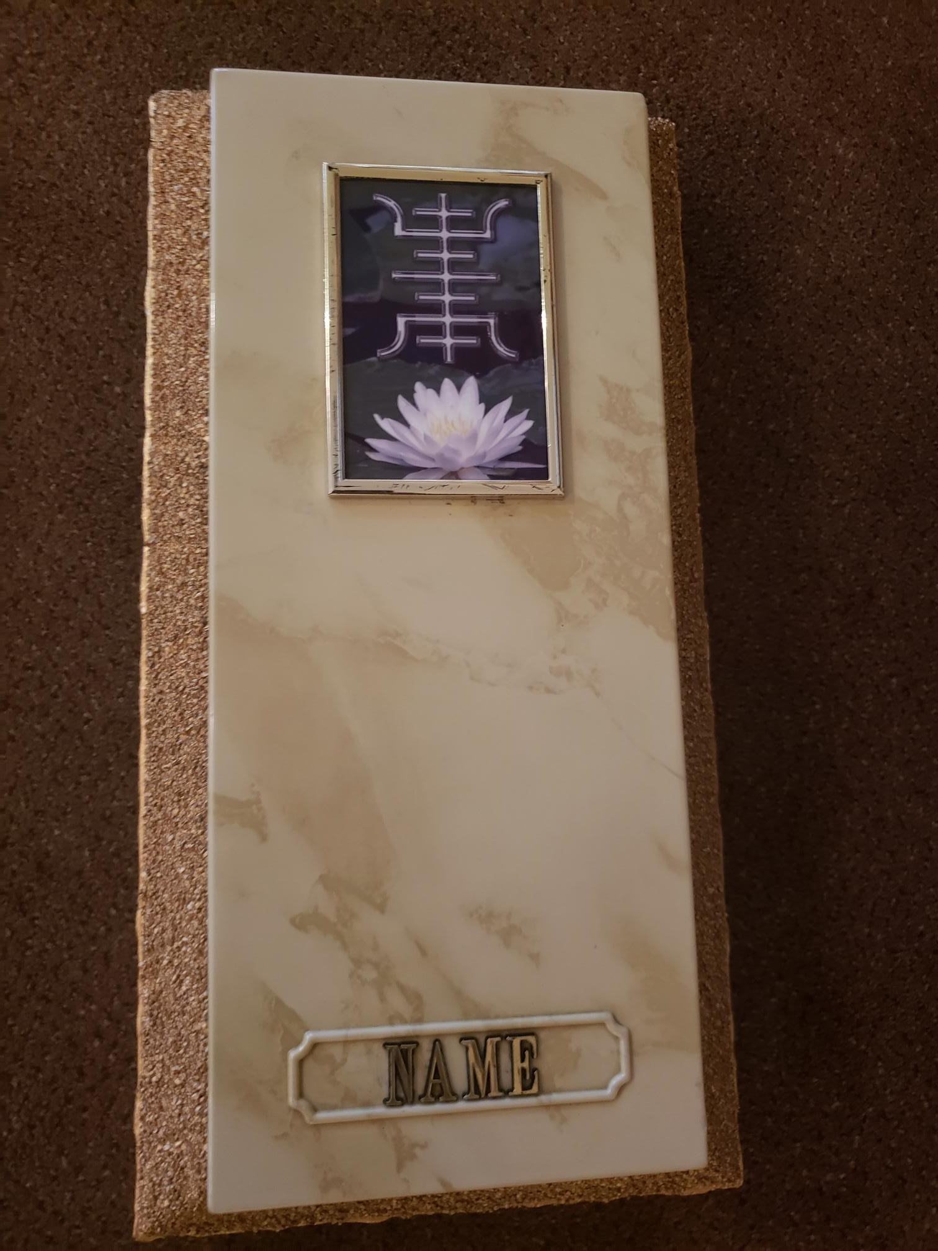

Top of lid to have Lotus Long life symbol (CC025). The name and year on the bottom of the vault needs to be exactly how it is on the top of the document (Chinese name, English name, Year of Birth, Year of Death). Follow the photo for reference.

